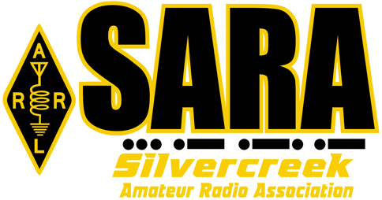

SARA Meeting Agenda – May 16, 2024

- Call to Order: Welcome SARA Members and Friends:
  - Visitor introductions

- Announcements:
  - Final Call: Dues are Due
  - Next Scheduled VE Session Saturday, June 1st, 2024, Medina County
  - Other/Member Announcements

- Approval of March 2024 Meeting Minutes: Fred Howe WA8KOC / Mike Schaffter KE8QWE

- April 2024 Treasurer’s Report: Mike Schaffter KE8QWE / Jeff Royer W8TB

- Club Business:
  - Field Day T-Shirt Delivery
  - Allan “Zeke” Zadiraka ^{(sk)} Estate Report -- W8TB Jeff
  - SARA POTA Event -- W8HRF Josh
  - Field Day Update – KD8SLG Nick
  - Field Day Antenna Update – N8EI Jason
  - SARA Family Picnic – Russ Orr KD8VYT
  - Bob Bohn Memorial FOX HUNT – Committee Organization
  - Spring Build Final Report – Antenna Build Group
- Around the Room

- 50/50 Raffle & Adjournment

- TechTalk: Parks On The Air – Lane Yeria, KD8JJF
Next SARA Business Meeting June 20, 2024, at 7:00 p.m. Wadsworth Eagles
Plan to attend and bring a friend!

